Diagnostics testing

# Generic buffer read

Verify that reading TB.DIAGNOSTIC_DATA is available while PST is running, and returns an error if the read segment number is beyond the already populated segment of the buffer.

# Partial stroke test

Verify implementation against requirement. Note any bugs (doesn’t work at all), discrepancies (parameters, ranges, etc.)

To execute PST, configure PST and PST trigger. Then trigger it. To trigger “on demand”, use OFFLINE_DIAGNOSTIC=”90. Start Partial stroke test”

## Control limits

In PST_CONFIG, disable control limits

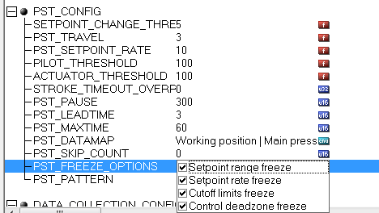

Set control limits to interfere with PST range, including deadzone≠0.

Run PST.

Verify that while PST is running,

* ACTIVE_CONTROL_SET.DEADZONE=0
* CUTOFF_{LO,HI} are disabled
* Setpoint range and rate limits are disabled

Verify that when PST is completed, PST data violate preset limits (e.g. position outside range limits)

Verify that when PST is completed, all limits are restored.

# Diagnostic signature testing

Execute one of the marked diagnostic procedures configured so that the raw resulting data would have more than 3000 points.

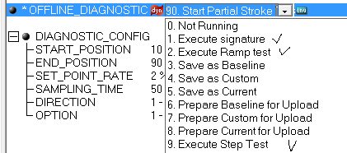

Verify that the uploaded buffer has sensible data and not garbage toward the end.

NOTE: This may require a fix in DTM which limits tests to 60 s.